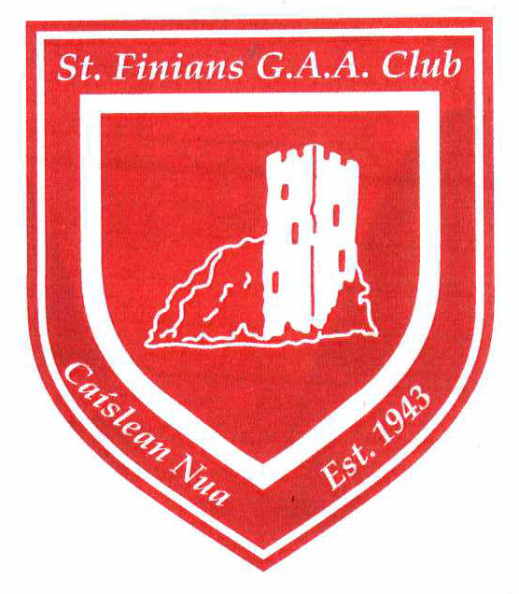Naomh FinnÉin C.L.G.

Established 1943

**Players Code of Conduct**

***Young players who play for St. Finians GAA club should:***

* *Be safe and feel safe.*
* *Have fun and experience a sense of enjoyment and fulfilment.*
* *Be treated with respect, dignity and sensitivity.*
* *Comment and make suggestions in a constructive manner.*
* *Participate in games and competitions at levels with which they feel comfortable.*
* *Be listened to.*
* *Play fairly, do their best and enjoy themselves.*
* *Respect fellow team members regardless of ability, ethnic origin, cultural background or religion.*
* *Support fellow team members whether they do well or not so well.*
* *Respect their team, their club and their family with pride and dignity.*
* *Respect all coaches, mentors, officials and their opponents.*
* *Be gracious in defeat and modest in victory.*
* *Shake hands before and after their games irrespective of the result.*

***Young players who play for St. Finians GAA club should not:***

* *Cheat – always play by the rules.*
* *Spread rumours.*
* *Tell lies about adults or other young people.*
* *Shout or argue with an official, team mates or opponents or use violence.*
* *Use unfair or bullying tactics (verbally, physically or via social media e.g. Facebook, Twitter) to gain advantage or isolate other players.*
* *Play or train if they feel unwell or injured.*
* *Use unacceptable language or racial and/or sectarian references.*

**Parents Code of Conduct**

**Parents/Guardians should encourage their child to:**

* Always play by the rules.
* Improve their skills levels.
* Appreciate everybody on their team, regardless of ability.

**Parents/Guardians should lead by example:**

* Adopt a positive attitude to their children’s participation in our games.
* Respect officials’ decisions and encourage children to do likewise.
* Do not exert undue pressure on your child.
* Never admonish your own child or any other child for their standard of play.
* Be realistic in your expectations.
* Show approval for effort, not just results.
* Never embarrass a child or use sarcastic remarks towards a player.
* Applaud good play from all teams.
* Do not criticise playing performances. Identify how improvements may be made.
* Do not seek to unfairly affect a game or player.
* Do not enter the field of play unless specifically invited to do so by an official in charge.

**Parents/Guardians should:**

* Drop off their children to training/matches on time and collect them from training/matches on time also**. It is not the responsibility of the coach to wait with the child until the parent/guardian arrives. If for any reason you are running late please contact the coach who is with your child so that he/she can keep another adult on the premises with them while they await your arrival.**
* Inform the coaches, and any other relevant Club personnel of any changes in their child’s medical or dietary requirements prior to coaching sessions, games or other related activities.
* Ensure that their child punctually attends coaching sessions/games or other related activities.
* Provide their child with adequate clothing and equipment as maybe required for the playing of our games, including for example **two** hurls per player, helmet, shin guards (when required), gum shields (compulsory for Gaelic football)
* Show approval whether the team wins, loses or draws a game.

*The St. Finians Code of Conduct has been adapted and abridged from the GAA Code of Conduct Guidelines 2014, 2016, 2017 .*