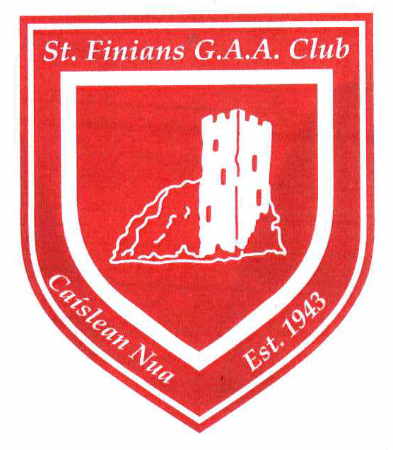Naomh FinnÉin C.L.G.
Established 1943
E-Vetting in the GAA
Please read the information and guidance below before commencing this process. The online vetting form can be found here.
Vetting in the GAA
The GAA has a long established principle of vetting any person who, on our behalf, works with children or vulnerable adults in our Association. This principle is enshrined in rule through our Code of Best Practice in Youth Sport and has become part of the overall recruitment and selection process for those who wish to work with us in the GAA, in a voluntary or paid role.
Vetting services for the Association are currently overseen by the National Childrens Office in Croke Park while Comhairle Uladh acts on our behalf in coordinating AccessNI services.
Our international units adhere to the legislative vetting and police background checks that are required in the jurisdiction in which they operate.
Legislation
The National Vetting Bureau (Children & Vulnerable Persons) Acts 2012 - 2016 commenced on 29th April 2016 and from that date a statutory obligation was placed upon the GAA to ensure that all persons who on our behalf undertook ‘relevant work’ with children has been vetted prior to taking up that role in Ireland.
The term ‘relevant work’ in the GAA includes any role of responsibility such as coaching, managing or training underage teams or indeed adult teams that contain any player under 18 yrs. of age. It also applies to organising underage activities or refereeing underage games.
The Act also established the National Vetting Bureau (NVB) to oversee the e-vetting services previously administered by the Garda Central Vetting Unit.
Who needs to be vetted?
In the GAA any person who carries out a role of responsibility such as coaching, managing or training underage teams or indeed adult teams that contain any player under 18 yrs. of age must be vetted. It also applies to organising underage activities or refereeing underage games. Thereafter, each club shall decide if other roles merit a person being vetted.
Any person who was working with children in the GAA prior to the commencement of the Act and was not previously vetted for that role may continue in that capacity but must apply as a matter of priority to be vetted by the GAA under what is termed ‘retrospective vetting’. This term and these conditions are allowed for in the Act.
What if the applicant is under 18 yrs. of age?
GAA vetting services are available to any person over 16 yrs. of age fulfilling a role of responsibility with children or vulnerable adults. A parental consent form (NVB Parent/Guardian Consent Form) must be completed, this is available here, for applicants between 16 and 18 yrs. of age
Is it an offence if you are not vetted?
It is now a criminal offence, for a person acting on behalf of the GAA, or for the GAA as an Association to permit any person to commence working with children on behalf of the Association without that person first obtaining a vetting disclosure from the National Vetting Bureau in respect of the role for which they have been recruited. It is also a breach of GAA rule if you are working with children or vulnerable adults on behalf of the Association and have not been vetted.
E-Vetting
When the Vetting Act came into being on 29 April 2016 the GAA became one of the first organisations to replace ‘paper vetting’ with a new on line or E –Vetting system.
E-Vetting replaces all previous paper vetting systems which also brings us in line with similar e-vetting services as coordinated by Ulster GAA for AccessNI.
How can you be vetted through the GAA?
Vetting for a member of the GAA involves 3 easy to follow steps as follows:
Step 1 The initial application vetting process at Club level
You must in the first instance complete the GAA E-Vetting ID Form. This form compels you to provide proof of your identity to the Club Children’s Officer, who must verify that they have received the ID verification as required. The ID verification may be retained by the Club Children’s Officer for the duration of the e-vetting process or it may be attached by you at Step 2 to the On Line Vetting application Form.
The primary purpose of this form is for you to provide your name, address, club, role for which you applied, and to present your ID (e.g. copy of your passport plus a utility bill showing your current address) plus a valid email address for future reference. The full list of documents which are accepted for verification can be found here
Click here for the GAA E-Vetting ID Form
Step 2 Completing the Vetting Application form
The GAA on-line E-Vetting Application Form is available to download.
Once you complete the GAA on-line E-Vetting Application Form the information provided is forwarded to the NVB by the GAA and you will receive an on-line NVB Vetting Form to complete.
The details entered will be emailed back to you, for your own records. Your Club Secretary will also receive an email informing him/her that you have applied as a member of the club, to be issued with the NVB Vetting Application Form.
Click here for GAA on-line E-Vetting application form
Step 3 NVB Vetting Application form
The NVB will issue you with the NVB Vetting Application form. This will be issued to the email address you provided in Step 2.
Completing this form is a confidential matter between you and the NVB. All sections of the form including current and previous addresses, email address and contact telephone numbers, information on convictions and prosecutions (if any), plus other information will be required when completing the form.
Once all sections of the form have been answered this then completes your application process for E Vetting in the GAA and within a short period of time you shall be contacted by the GAA to informing you as to the outcome of the vetting application.
You and your Club Secretary will be notified when the vetting process has been completed.

All Vetting queries should be forwarded to evetting@gaa.ie

